**Module Two**

**Electric Potentials**

**2.0 Electric Potential**

A test charge $q_{o}$ placed in an electric field **E** will experience a force given as $q_{o}E$. When the test charge is moved in the field by some external agent, the work done by the field on the charge is equal to the negative of the work done by the external agent causing the displacement. The **electric potential difference** between two points A and B in an electric field is defined as the work done in moving a test charge from one point to another. The work done by the external agent in moving the test charge q0 from point A to point B along an arbitrary path in an electric field is therefore given as

$${W(A→B )}_{av}= -q_{0} \int_{A}^{B}{E.dl}- - - - - - - - 2.1$$

Where dl is an infinitesimal increment of displacement and integral is taken along any path in space from point A to point B

This equation is valid because the force is a conservative force. A force is said to be conservative if the work done by or against it in moving an object is independent of the object’ s path. The implication of this statement is that the work done by a conservative force depends only on the initial and final positions on an object.

The work done by the electric field on the charge as it moves from A to B is

$${W(A→B )}_{E}= -q_{0} \int_{A}^{B}{E.dl}- - - - 2.2$$

This implies,

$${W(A→B )}_{av}=-{W(A→B )}_{E}$$

Since the change in potential energy $∆U$ is equal to the work done on the particle by the electric field, we have

$$∆U=U_{b}-U_{a}=-{W\left(A→B \right)}_{E}- - - - - - 2.3$$

$$∆U=q_{0} \int_{A}^{B}{E.dl}=q_{o}\left(V_{b}-V_{a}\right)$$

$$V_{b}-V_{a}=\frac{∆U}{q_{o}}=-\int_{A}^{B}{E.dl}- - - - - - 2.4$$

Hence, the electric potential difference $(V_{B} - V_{A})$ between two points A and B may also be defined as the potential energy per unit charge (see Equation 2.1).

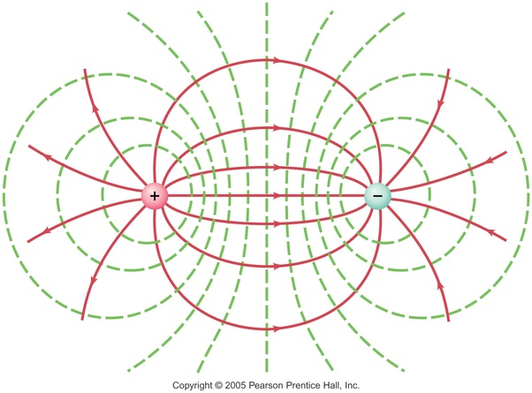

If we consider an isolated positive charge Q. The potential difference between two points A and B is given by Equation (1.36),

$$V_{B}-V_{A}=-\int_{A}^{B}{E∙dl}$$

where A and B are the two arbitrary points, as Using Equation (11.4), we have,

$$V_{b}-V_{a}=-\int_{A}^{B}{\frac{kQ}{r^{2}}\hat{r}dl}=KQ\left(\frac{1}{r_{b}}-\frac{1}{r_{a}}\right)- - - - - - -2.5$$

Consider the potential energy of a system of two charged particles. If $V_{A}$ is the potential at a point A due to charge $Q_{1}$, then the work an external agent must do to bring a second charge $Q_{2}$ from infinity to point A is given as:

$$W=Q_{2}V_{1}=Q_{2}\frac{KQ_{1}}{r_{12}}=\frac{K{Q_{1}Q}_{1}}{r_{12}}- - - - - - -2.6$$

Where $r_{12}$ is the distance between the two charges.

By definition, the work done by a charged particle to change the position of another charges particle is equal to the potential energy of a system of two charges particle. Therefore, we can express the potential energy as

$$U=k\sum_{pairs}{\frac{Q_{1}Q_{2}}{r}}- - - - - - 2.7$$

Where the summation is over all pairs $Q_{1}and Q_{2}$, among n charge, each pair is separated by distance r

**2.1 Potential due to Point Charge**

The integral of $E∙dl$ is independent of the path between points A and B because the electric field of a point charge is conservative. The potential difference between any two points A and B in a field created by a point charge depends only on the radial coordinate’s $r_{A}$ and $r_{B}$ of the points. It is customary to choose the reference of electric potential to be zero at $r_{A}=∞$. Then Equation 11.37, with these modifications becomes

$$V_{b}=\frac{kQ}{r}$$

In general, for any arbitrary point, the electric potential at r relative to infinity is given as

$$V=\frac{kQ}{r}- - - - - - - -2.8$$

When Q is a positive charge, V is positive. This implies that work is done by an external force in moving a positive charge to the point concerned since Q repels the charge. When Q is a negative charge, V is negative. This implies that the field itself does work when a positive charge is moved to the point concerned, since it is now attracted by Q.

In general, for any arbitrary point, the electric potential at r relative to infinity is given as

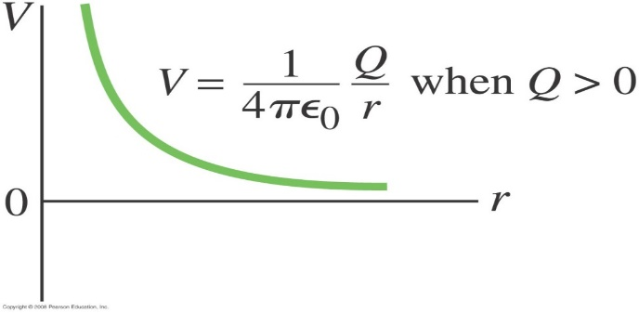 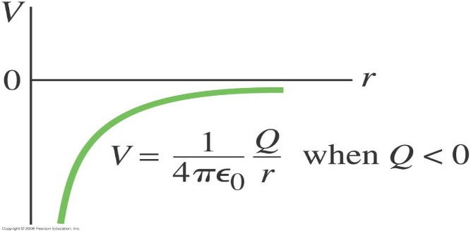

**2.2 Relationship between Electric Field E and Electric Potential V**

The electric field E and the electric potential V are related by Equation 11.36, as

$$V_{B}-V_{A}=\frac{∆U}{q_{o}}=-\int_{A}^{B}{E∙dl}- - - - - - -2.8$$

In infinitesimal form, the Equation 11.36 can be written as

$$∆V=-E∆l=-E∆lcos θ$$

where 9 is the angle between E and $∆l$

The above expression becomes

$$\frac{ΔV}{Δl}=-E\cos{θ}=-E^{'}- - - - - - 2.9$$

where E is the component of E in the direction of the displacement Al. So in differential limit form,

$$E=-\frac{dV}{dl}- - - - - -2.10$$

Suppose E is directed radically outward, and $dl=dr$ is a radial displacement in the direction of E, then,

$$E_{r}=-\frac{dV}{dr}$$

If the electric potential is a function of then the components of the electric field are specified by partial derivatives:

$$E_{x}=-\frac{dV}{dx};E_{y}=-\frac{dV}{dy};E_{z}=-\frac{dV}{dz}- - -- - - 2.11$$

**2.3. Electric Potential due to Continuous Charge Distribution**

Consider a finite charge distribution shown in Figure 11.9. We wish to determine the electric potential at point P due to this charge distribution. We divide the distribution into infinitesimal elements of charge $dq$, which contributes an electric potential $dV$ at the point P. For the element $dq$ we obtain:

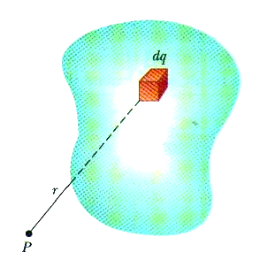

$$dV=\frac{1}{4πε_{o}}\frac{dq}{r}- - - - - -2.12$$

where r is the distance from $dq$ to the point P. The total electric potential at P due to the charge distribution is obtained by integrating Equation 2.12. Therefore, where r is the distance from an infinitesimal element of charge $dq$ to the point P.

**2.4. Equipotential Surfaces**

An equipotential is a surface or volume over which the potential is constant. The surface of a conductor is an equipotential surface. The space inside a hollow charged conductor is also an equipotential volume.

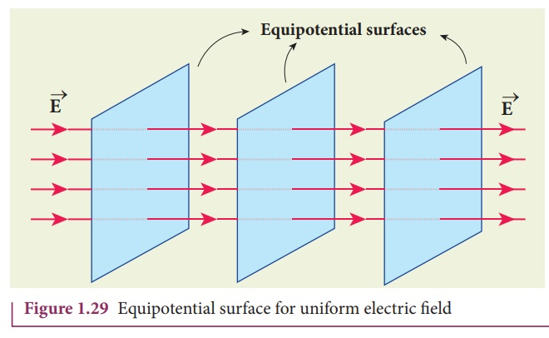

There is no electric field in an equipotential surface, for there is no potential gradient, i.e. $dV=E.dl=0$. An equipotential is therefore always at a right angle to the lines of force. For example, Figure 11.10 shows parallel conducting plates like those in a capacitor. The electric field lines are perpendicular to the plates and the equipotential lines are parallel to the plates! The dashed lines are equipotential lines while the solid lines are electric field lines.

Equipotential surfaces are always perpendicular to field lines; they are always closed surfaces (unlike field lines, which begin and end on charges).